Evaluación diagnóstica 2° año S. B. Asignatura Inglés. Ciclo lectivo 2020 Alumno:_____________________
Complete the dialogue between the Hotel receptionist and the new guest:
Mrs. Harrison: ______________________________________________
Man: My name is Tom Merton.
Mrs. Harrison:_______________________________________________
Man: My address is 4 Park Road St., London.
Mrs. Harrison:________________________________________________
Man: I’m English.
Mrs. Harrison:________________________________________________
Man: It’s one, double five, two, three, six, seven.
Mrs. Harrison: Welcome to our Hotel!
Read the text, write the people’s name and answer the questions:
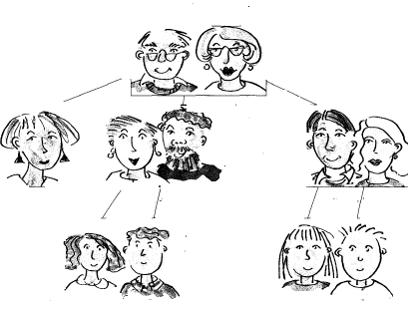
My name is Peter. I’m 13 years old and my sister Karen is 16. My father is Billy, he is 40 years old. My mum is 38 and her name is Tricia. We are English, but not all my family is from England. My father’s brother, my uncle, is 43, his name is Andy. His wife Martha isn´t English, she is from Mexico. Their children are Sophie and Brian. They are teens and they are 10 years old. My aunt Sylvia is single.
My grandparents are Italian. My grandfather’s name is Tony and my grandmother’s name is María. They are 80 years old.
Peter
- How old is Sophie’s father?_____________________________________________________________________
- Where is María from?_________________________________________________________________________
- Is Karen Spanish?_____________________________________________________________________________
- How old is Brian’s aunt?________________________________________________________________________
- Is aunt Sylvia married?_________________________________________________________________________
- Are Peter’s grandparents from Mexico?___________________________________________________________
- How many women are there in the family?_________________________________________________________
- How old are the twins?_________________________________________________________________________
Write the following information in numbers:
- The days in seven weeks:_______________________________________________________________________
- The days in a year:____________________________________________________________________________
- The weeks in a year:___________________________________________________________________________
- The months in seven years:_____________________________________________________________________
- The amount of chair legs in the classroom:_________________________________________________________
- 416 + 218:___________________________________________________________________________________
- 344 + 262:__________________________________________________________________________________
Write the time in words:
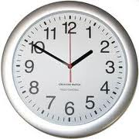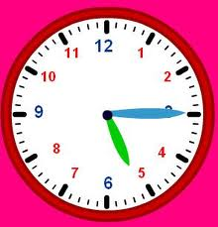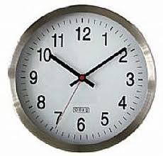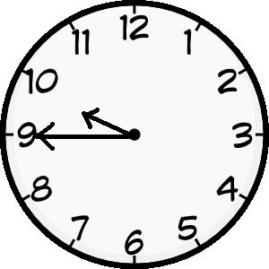
1)_______________________________________________________________________________________________
2)_______________________________________________________________________________________________
3)_______________________________________________________________________________________________
4)_______________________________________________________________________________________________
5)_______________________________________________________________________________________________

Read about Jenny:


Hi! I’m Jenny Burrows. I’m 13 years old and I’m from Australia. My birthday is on 8th April. My favourite objects are my P.C, my bike and my smartphone. My favourite food is pizza. I love my dog Mobo. It’s very intelligent. He’s my best friend. I go to school from Monday to Friday. I like skateboarding.
Find in the text:
- A day of the week:_________________________________________________
- A month:_________________________________________________________
- A country:________________________________________________________
- An ordinal number:_________________________________________________
- A small object:____________________________________________________
- An adjective:_______________________________________
- A word for food:____________________________________
- A noun:___________________________________________
- A big object:_______________________________________
- A word indicating possession:_________________________
Read the fact file and write a paragraph describing this person: Use verbs “is”, “can” and “has got”
Name: Peter,

Born: Argentina,
Description: tall, handsome, brown hair
Profession: musician, artist,
Possessions: A guitar and a piano
Abilities: Sing and play the piano very well.

Write the days of the week:

1)__________________________comes after Monday.
2)__________________________is between Friday and Wednesday.
3)__________________________is the last day of the week.
4)__________________________is the first day of the week.

Answer these personal questions:

- How old are you?_________________________________________________________________
- Where do you live?_______________________________________________________________
- Where is your school?_____________________________________________________________
- What’s your favourite football team?_________________________________________________
- When’s your birthday?_____________________________________________________________
- Can you crochet?_________________________________________________________________
- Have you got a motorcycle?_________________________________________________________
- Are your friends River Plate’s fans?____________________________________________________
- Do you go to gym classes?___________________________________________________________

Complete the sentences with one word from each box:
A  AN | AMERICAN  FRENCH  INTERNATIONAL  ENGLISH  JAPANESE  GERMAN  ITALIAN | CAR  UNIVERSITY  CITY  CAMERA  DRINK  LANGUAGE  CAR
1) A Cadillac is__________________________________________________________________
2) Champagne is________________________________________________________________
3) A Konica Minolta is____________________________________________________________
4) English is____________________________________________________________________
5) Milan is_____________________________________________________________________
6) A Mercedes Benz is___________________________________________________________
7) Oxford is____________________________________________________________________
3) Present simple, present continuous?
1. María ________________________ (work) for a TV station.
2. At the moment she ____________________ (travel) in the Sahara Desert.
3. Marta __________________________ (not live) in Africa.
4. She ___________________________ (stay) in Africa at the moment.
5. My sister __________________________ (walk) to school every day.
6. We __________________________ (have) lunch now.
7. I never __________________________ (stay in) on Saturday evening.
8. My mum _________________________ (not work) today.
9. Let´s go out. It ______________________________ (not rain) now.
10. She always_________________(go) to bed after midnight.

Read and answer:


Hello! I'm Brenda. I am 15 years old and I live in Mar del Plata. In summer, in my free time, I go to the beach to play volleyball with my friends.
In this photo I'm playing volleyball with Natalie. She is my best friend. She doesn't like sports but I do. I also like dancing and playing volleyball.
In the photo we are playing for the USA team. I'm the girl wearing glasses. I'm running towards Natalie.
Natalie always comes home because she likes my brother Brian.

1) Where does Brenda live?___________________________________________________

2) What is she doing in the photo?______________________________________________

3) Does Natalie like sports?___________________________________________________

4) Who is wearing glasses?___________________________________________________

5) How often does Natalie visit Brenda?_________________________________________

6) Where do they go to play volleyball?_________________________________________

