Evaluación Diagnóstica 1° año S.B. Asignatura: Inglés, ciclo lectivo 2020 Alumno:_______________________
Answer the questions about the person in the identity card:
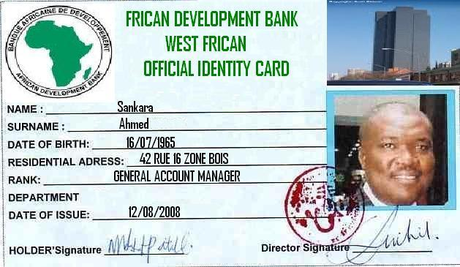
- What’s his name?_______________________________
- What’s his surname?____________________________
- What´s his address?_____________________________
- How old is he?_________________________________
- Where’s he from? _____________________________
Complete the sentences with: There is or There are:
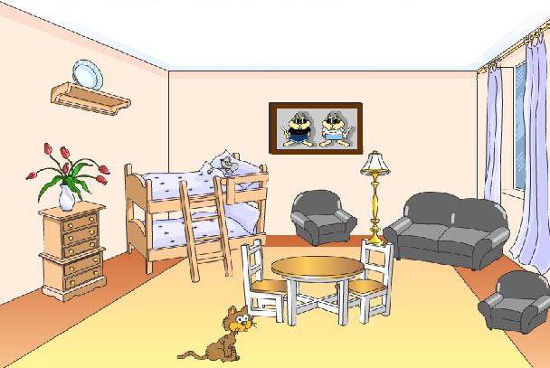
- _______________three armchairs in the room.
- _______________a cat in the room.
- _______________two chairs.
- _______________two beds.
- _______________a lamp in the room?
- ______________a rat in the bed?
Complete the sentences using the following prepositions: under, in, on, behind, between, and next to.
- The lamp is _____________the armchairs.
- The plate is ____________the shelf.
- The wardrobe is ____________the beds.
- There is a rat_____________the bed.
- The flowers are____________the shelf.
Answer these questions:
- Is there a computer in your bedroom?____________________________________________________________
- Are you a sportsperson?_______________________________________________________________________
- Have you got a green sweater?__________________________________________________________________
- Can you swim?_______________________________________________________________________________
- Is your friend tall?____________________________________________________________________________
- Do you like pizza?_____________________________________________________________________________
- What is there in your schoolbag?_________________________________________________________________
Write these numbers in words:
756:________________________________________________________________________________________
482:________________________________________________________________________________________
106:________________________________________________________________________________________
899:________________________________________________________________________________________
222:________________________________________________________________________________________Read the text and answer the questions:
At Home:
Kelly is with her family at home. Now, she is playing Bingo with her grandmother. Kelly’s brother is doing his homework, and her grandfather is watching T.V. Kelly’s father is cooking dinner. Kelly’s baby sister is sleeping at the moment. Mum is with her.
- Where is Kelly?_______________________________________________________________________________
- Where is Kelly’s father?________________________________________________________________________
- What is Kelly’s grandfather doing?________________________________________________________________
- Where are Mum and the baby?__________________________________________________________________
- How many members of the family are there in the house?____________________________________________
Write as many elements you can remember about:
FOOD:_____________________________________________________________________________________________
DRINKS:___________________________________________________________________________________________ANIMALS:__________________________________________________________________________________________
FURNITURE:________________________________________________________________________________________
CLOTHES:__________________________________________________________________________________________
ADJECTIVES:________________________________________________________________________________________
WORDS RELATED TO SCHOOL:_________________________________________________________________________
Choose elements from each group and make 5 sentences:
__________________________________________________________________________________________________________________________________________________________________________________________________________________________________________________________________________________________________________________________________________________________________________________________________________________________________________________________________________________________________________

Read the description and look at the picture. Correct the mistakes:
This is a picture of my music teacher. She is very short.
She has got a guitar in her hand.
She has got grey short hair. She is very old.

(Negative) (Affirmative)

___________________________________ ______________________________________________
___________________________________ ______________________________________________
___________________________________ ______________________________________________
___________________________________ ______________________________________________
___________________________________ ______________________________________________

