COVID-19
OBJECTIVES
- To make students investigate about the causes and effects of the recent virus spread around the world.
- To be aware of the correct ways of prevention.
Year 2020
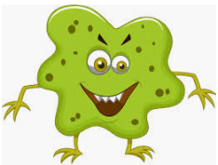

- CHOOSE THE CORRECT OPTION TO COMPLETE THE SENTENCE (IN SOME CASES MORE THAN ONE OPTION IS POSSIBLE)

MY NAME IS…..
- INFLUENZA B) COLD C) CORONAVIRUS

I COME FROM………….. IN CHINA
- BEIJING B) WUHAN C) SHANGHAI

I AFFECT PRINCIPALLY…
- OLD PEOPLE B) ANIMALS C) CHILDREN D) ILL PEOPLE E) PLANTS

- LOOK AT THE PICTURES AND NAME THE MEANS OF TRANSMISSION
HUMAN CONTACT CONTAMINATED OBJECTS ANIMAL CONTACT AIR

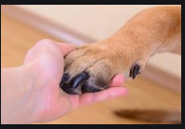

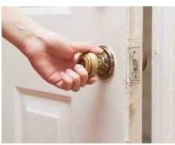


4
3
2
1

- WHAT ARE THE SYMPTOMS?
MAKE A TICK IN THE CORRECT SYMPTOM OF CORONAVIRUS
COUGH  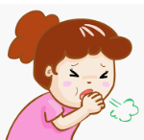 | FEVER  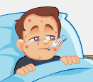 | BODY ACHE  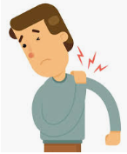 | DIARRHEA  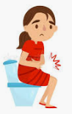 | DIFFICULTY TO BREATHE  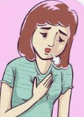 | VOMIT  

- HOW CAN WE PROTECT OURSELVES?
CIRCLE THE CORRECT WAY TO PROTECT OURSELVES
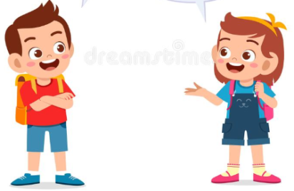

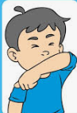
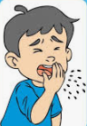
- SNEEZE ON YOUR INNER ELBOW 2. AVOID CONTACT WITH PEOPLE

3. WASH YOUR HANDS 4. DON’T TOUCH YOUR EYES, NOSE AND MOUTH
REGULARLY
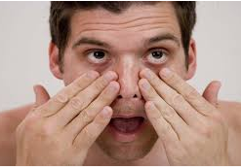
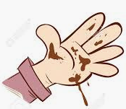
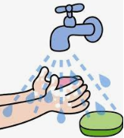

- WHAT IS THE TREATMENT?
WRITE TRUE OR FALSE TO THESE STATEMENTS
- ANTIBIOTICS CAN’T CURE CORONAVIRUS ___________
- PILLS CAN CURE CORONAVIRUS ____________
- THERE ISN’T A CURE FOR CORONAVIRUS YET _____________

